**Fuzzy Controller for Quarter Car Active Suspension System**

# **Introduction**

Arabaların sürücü konforunu artırma için birçok çalışma gerçekleştirilmektedir. Bu konfor sağlama çalışmalarından biriside arabaların süspansiyon sistemleridir. Önceleri kontrol sistemleri olmayan pasif süspansiyon sistemleri ile tekerleklerden gelen titreşimleri ya da tümseklerde oluşan salınımları sönümlenerek azaltılmaya çalışılıyordu. Daha sonra kontrolcü de eklenerek aktif kontrol sistemleri geliştirildi. Henüz aktive kontrol sistemleri müşterilerin talep ettiği seviyede araç güvenliği ve konforunu karşılayamamaktadır. Aktive Süspansiyon sismtemlerin de kullanılan kontrolcü için geliştirilen birçok teknik literatürde bulunmaktadır. Fuzzy logic ise bunlardan biridir. Fuzzy Logic in siyah-beyaz dışında gri alanları da değerlendirme ve ona göre sonuç üretebilme konusundaki başarısı sayesinde daha hızlı titreşimleri sönümleme başarımı elde edilebilmektedir. Kontrolcünün kontrol ettiği aktuatör araçta car body ve tekerlekler arasında yerleştirilmiştir. Ve tekerleklerde oluşan aşağı ve yukarı hareketlerde car body ile tekerlek arasındaki mesafeyi azaltıp artırarak car body nin dikey eksende herhangi bir hareket etmemesini yada hareketini minimize etmeyi sağlamaktadır.

Aktif süspansiyon sistemler kompleks ve nonlinear sistemler olmasından dolayı matematiksel olarak model tabanlı kontrol metotlar uygulanabilir olmamaktadır. Bu sebeple Fuzzy set tabanlı kontrol sistemleri nonlinear dinamik sistemleri kullanılmaktadır. Kontrollör için literatürde birçok metot kullanılmışıtr. Bunlar PID (Proportional-Integral-Derivative) [X2], MPC (Model Predictive Control) [X1], LQG (Linear Quadratic Gaussian) [X3], H-infinity [X4], SMC (Sliding Mode Control) [X5] and Fuzzy [X6]. (Burdaki makale konularında biraz detay bilgilerin verilmesi.)

Literatürdeki çalışmalar da merbership functions lar üçgen ve trapozoidal olarak yapılmıştır. Ve genel olarak değer aralıkları eşit olarak belirlenmiştir. Bu çalışmada literatüreden farklı oarak fuzzy control membership function larında üçgen yada trapezoidal yerine gaussian membership function kullanılmıştır ve değer aralıkları optimum sonuç verecek şekilde ayarlanmıştır. Bu sayede makalede de gösterildiği gibi diğer membership function ların ürettiği konfordan daha fazla konfor sağlanmıştır.

# **Mathematical Model of Suspension System**

In active control, there is control input to manage the changing real time. There are many method for active control systems. In literature, the methods are fuzzy logic, PID control, model predictive control, adaptive and robust. The main purpose of suspension control, is to keep the vehicle vertical acceleration at zero or minimize it.

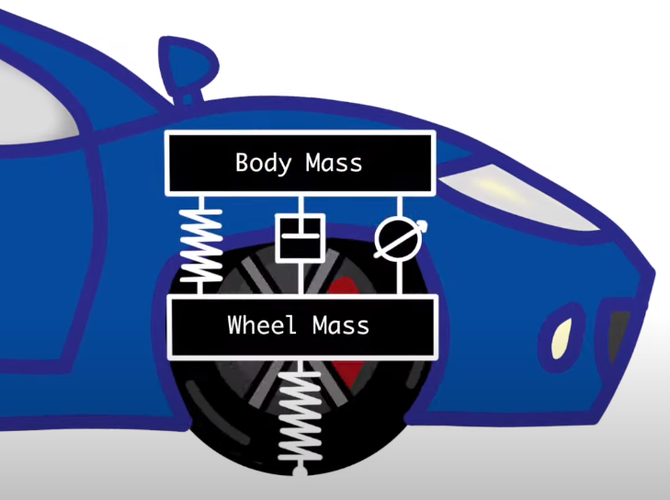Figure A1: Active control system for quarter car model.

Figure 1 shows the plant model for vehicle suspension model. In this model, there are vehicle sprung which is between vehicle and wheel, wheel sprung which is between wheel and road, damper and control input unit. The control input unit control the distance between vehicle body and wheel. In this study, the mathematical equations are prepared for this plant. The plant model design in MATLAB Simulink according to these equations. By using this establishment, the plant model was simulated.

When the Newton’s second law is applied to the plant model showing in figure 1, the equations showing below will obtain.

is acceleration on the vehicle body. The main purpose is making zero or minimize it. It depends on damper force, sprung force, and control input force.

is acceleration on the wheel. It depends on damper and sprung force between vehicle body and wheel, sprung force between wheel and road and control input force.

The state space equation of the model showing in figure 1 is below. Hence this model has two inputs (control input and road disturbance), the state space equation is better.

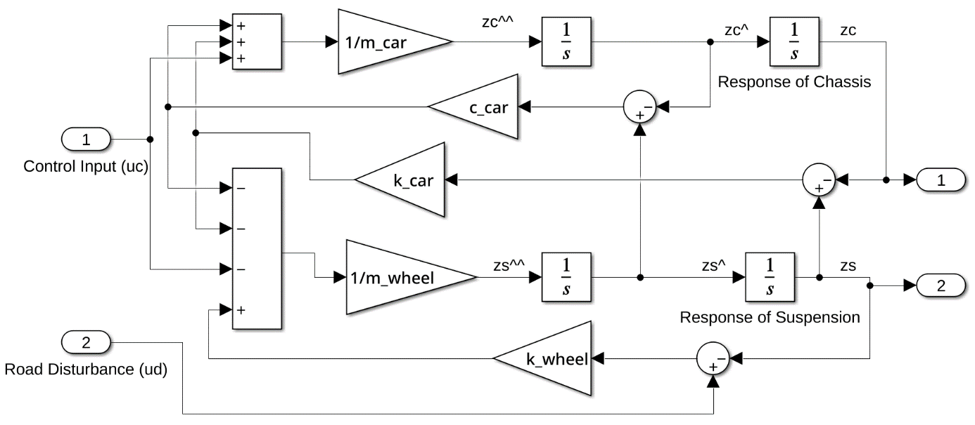

Fig. A2: Mathematical model belonging to quarter car suspension system.

# **Fuzzy Controller Design**

The fuzzy logic controller has two inputs that are car body displacement called as error () and velocity called as change in error (). It has one output that is desired actuator force uc. The Fuzzy Logic Controller has three steps that fuzzification, fuzzy inference system (FIS) and defuzzification. The real values are converted into fuzzy values in fuzzification step. FIS processes the fuzzy values and calculate output by using rules and data. The calculated output consists of fuzzy values. The output values convert into real values in defuzzification step. Mamdani approach was used for interpretation in rule base.

Membership functions are very important for rule base control systems. Defining of optimum interval for each member is provide significant conclusion. It is related to which plant is studied on. For the suspension systems, decreasing the zero parts is increasing the success rate. Triangular and trapezoidal functions of the members are mostly employed in literature. Nevertheless, gaussian function is more suitable for active suspension systems as indicated in this paper. Hence, gaussian membership function was employed in this study.

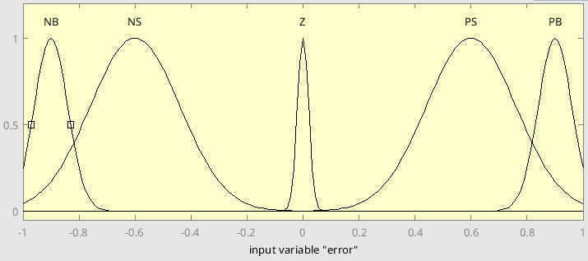

Figure X1: Membership function for “Error” input.

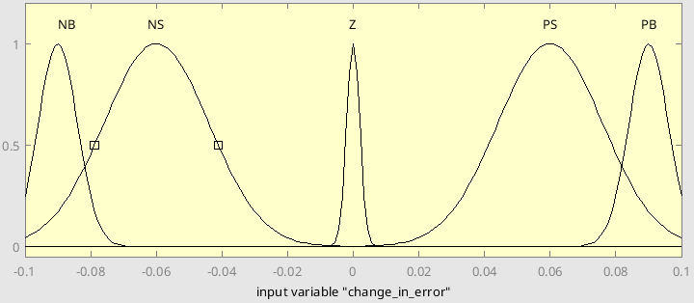

Figure X2: Membership function for “Change In Error” input.

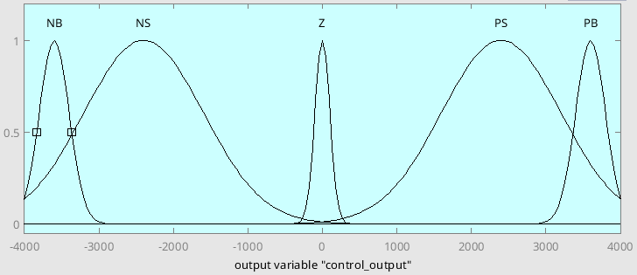

Figure X3: Membership function for “Actuator Force” output.

Figure X1 and X2 state for inputs and figure X3 states for output of the fuzzy logic control (FLC). The membership functions for each variable were divided into five categories. The abbreviations used in this study are; NB is Negative Big, NS is Negative Small, Z is Zero, PS is Positive Small and PB is Positive Big. The Big’s and Zero membership functions were attempted to small range, but the Small’s are wide range.

Table X1. Fuzzy logic rules table.

|  |  |  |  |  |  |
| --- | --- | --- | --- | --- | --- |
| e \ cE | NB | NS | Z | PS | PB |
| NB | NB | NB | NS | NS | Z |
| NS | NB | NS | NS | Z | PS |
| Z | NS | NS | Z | PS | PS |
| PS | NS | Z | PS | PS | PB |
| PB | Z | PS | PS | PB | PB |

Table X1 indicates the rule base of the FLC. Hence there are five members for each input, there are 25 control rules in the rule base.

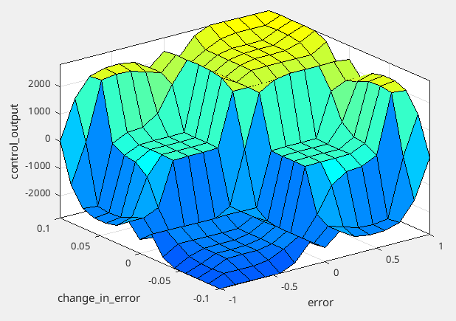

Figure X4: Fuzzy logic rules surface plot.

Figure X4 indicates the fuzzy logic rules surface plot for the input and output variables.

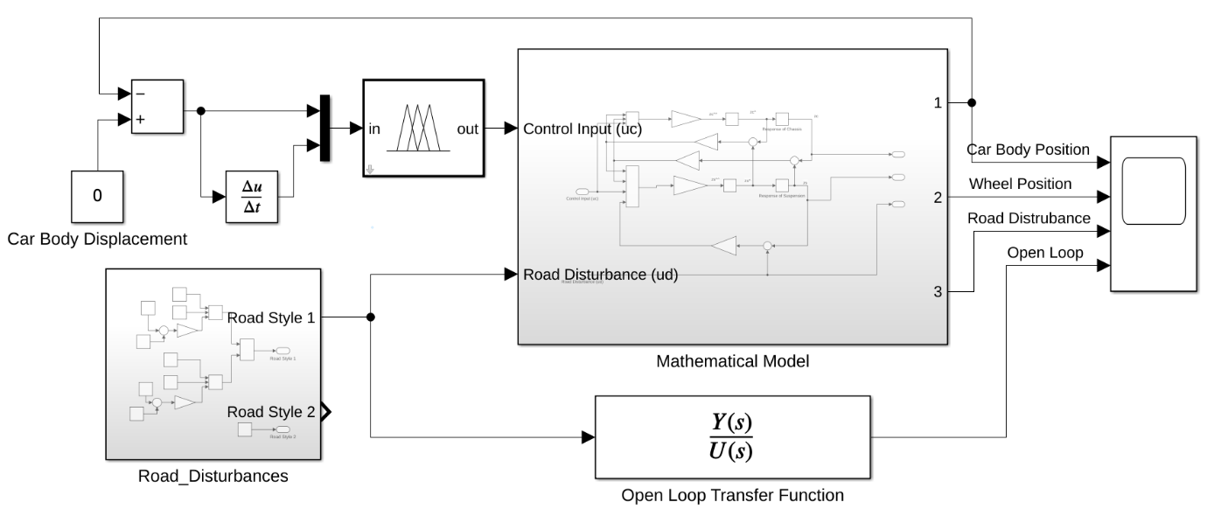

Fig. X5: The block diagram of fuzzy logic control.

Figure X5 indicates the

# **Simulation Results**

In this study,

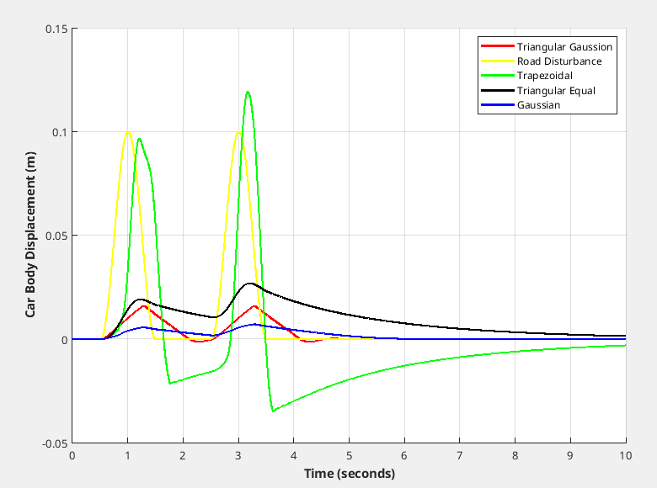

Figure X: Car body displacement for first road.

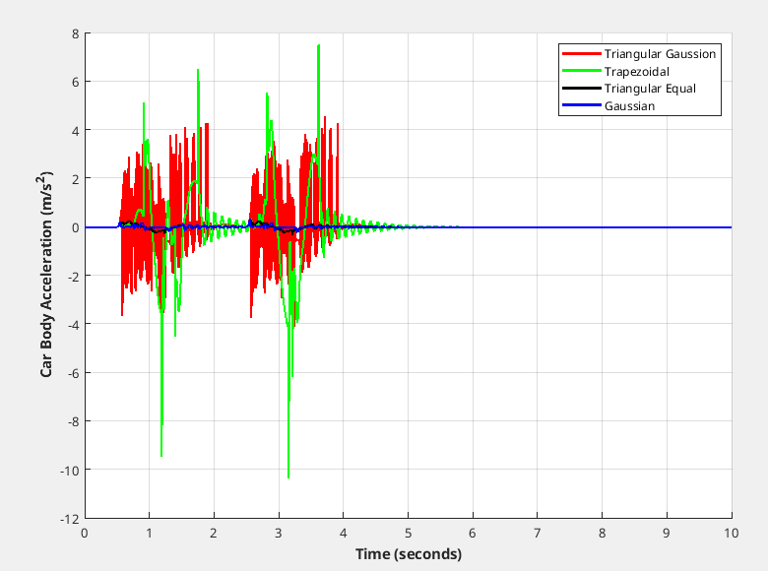

Figure X: Car body acceleration for first road.

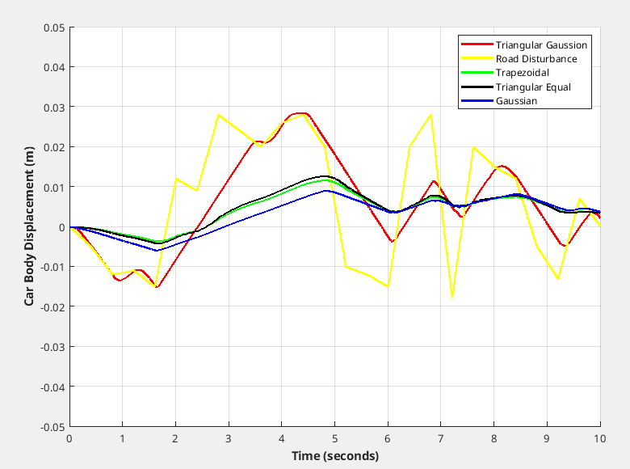

Figure X: Car body displacement for second road.

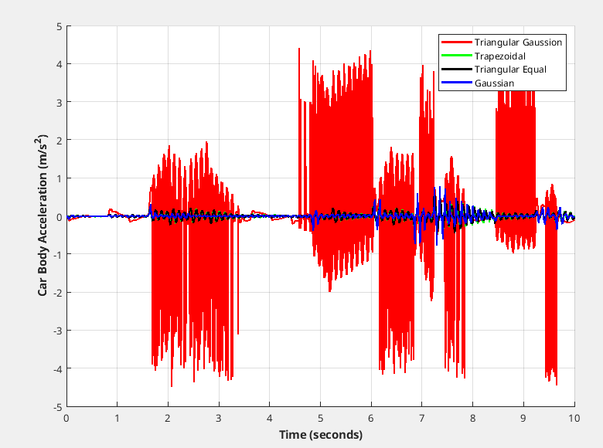

Figure X: Car body acceleration for second road.

# **Conclusion**

# **References**

[X1] Bououden, S. & Chadli, M. & Karimi, Hamid. (2015). A Robust Predictive Control Design for Nonlinear Active Suspension Systems. Asian Journal of Control. 18. 10.1002/asjc.1180.

[X2] Sharkawy, Abdel-Nasser & Ali, Ahmed & Ghazaly, Nouby & Abdel-Jaber, Gamal. (2015). PID CONTROLLER OF ACTIVE SUSPENSION SYSTEM FOR A QUARTER CAR MODEL. International Journal of Advances in Engineering & Technology. Vol. 8. 899-909.

[X3] Elmadany, Mohamed & Abduljabbar, Zuhair & Professor, Associate. (1999). Linear Quadratic Gaussian Control of a Quarter-Car Suspension. Vehicle System Dynamics - VEH SYST DYN. 32. 10.1076/vesd.32.6.479.4224.

[X4] Fallah, Saber & Bhat, Rama & Xie, Wen-Fang. (2009). H(infinity) Robust Control of Active Suspensions: A Practical Point of View. Proceedings of the American Control Conference. 1385 - 1390. 10.1109/ACC.2009.5160098.

[X5] Deshpande, Vaijayanti & Bhaskara, Mohan & Phadke, Shrivijay. (2012). Disturbance observer based sliding mode control of active suspension systems. Journal of Sound and Vibration. 333. 70-75. 10.1109/VSS.2012.6163480.

[X6] Palanisamy, Senthilkumar & Karuppan, Sivakumar. (2016). Fuzzy control of active suspension system. Journal of Vibroengineering. 18. 3197-3204. 10.21595/jve.2016.16699.